Experiment 11
The speed of light and other wave properties in a coaxial cable

Object: Time the speed of travel of a pulse along a coaxial cable to determine the speed of light in the material, and to investigate the nature of terminating the cable.

Prior to Lab: Look up in an appropriate handbook the dielectric constant for polyethylene. Predict the speed of light in polyethylene from this constant and the speed of light in a vacuum.

Apparatus: Oscilloscope, 1000 ft of RG-58U coaxial cable, differentiation circuit made up of a capacitor and resistor, square wave generator, and decade resistance boxes.

Discussion: A wave travelling in a material medium will travel slower than in a vacuum. The speed of the wave will be determined by the electrical characteristics of the dielectric medium filling the gap between the inner wire and outer cylindrical shielding in a coaxial cable according to 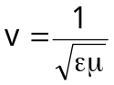where ε is the dielectric permittivity of the medium and μ is the magnetic permeability of the medium. For many dielectrics μ ≈ μ_{o}. Furthermore, ε = κε_{o} so the speed of the wave in a dielectric medium can be written as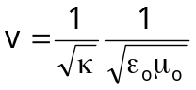or
where κ is the dielectric constant of the material and c is the speed of light in a vacuum. (At optical wavelengths 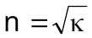 where n is the index of refraction of the material.)

Therefore, by directly measuring the time of travel of the pulse in the cable one can determine the speed of the wave travelling in the wire, and determine the dielectric constant for the material.

Further consideration of the behavior of waves travelling in a medium show that under most circumstances a portion, if not all, of the wave is reflected back along the cable when it reaches the opposite end. The reflected fraction of the voltage is determined by the impedance of the cable and the impedance of the terminating load according to

By examining the above equation, it is clear that the reflected voltage should be zero if the termination impedance or load, Z_{T}, is equal to the impedance of the cable, Z_{o}. The range of values for r would otherwise be from –1 (Z_{T} = 0)to +1 (Z_{T} = ∞). Where ±1 would represent perfect reflection with either an inverted pulse form (–1) or the identical pulse form (+1). Note that a pulse inversion is equivalent to a π shift in phase.
In this experiment Z_{o} is the impedance of the cable and equals 53.2 Ω. The termination impedance takes the form of a variable resistor thus Z_{T} equals R_{T}.
Procedure:
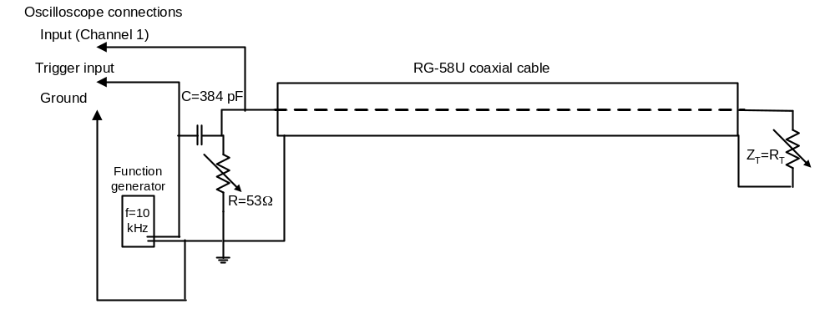
- Wire the circuit according to the diagram shown in the figure above.
- Adjust the output of the oscillator for a square wave output of about 1 to 4 volts at 10 kHz.
- Adjust the oscilloscope so it triggers from the square wave input, and measures the transmitted and reflected pulse voltages. (Get help from your instructor!)
- Determine the speed of the pulse in the cable by taking several measurements of the time for a round trip of the pulse as indicated by the oscilloscope trace. NOTE: With the oscilloscope you will measure the distance between the original pulse and the reflected pulse. You must then multiply the distance by the time/division setting selected. Division refers to major division on the CRT screen.
- Adjust the termination resistor to attempt to obtain the reflection for r =1,0 and –1. Record the values of R_{T} needed to get each of these values. Measure the height of the outgoing and reflected pulses. How close did you actually get to 1, 0 or –1?

Analysis and Report:
- From the data taken in step 4 of the procedure, calculate the speed of the pulse traveling through the cable.
- Determine the dielectric constant for the polyethylene insulator in the coaxial cable using the speed of the pulse calculated in step 1 and the first equation in a box on page 1 of the instructions. Compare this result with the known value for κ for polyethylene which is 2.3.
- Why were your results for the reflection fractions not perfect? What did you actually get as the extremes in this experiment? How close to r = 0 did you get? Why weren’t your results “perfect”?

